CLOTHES LABELS

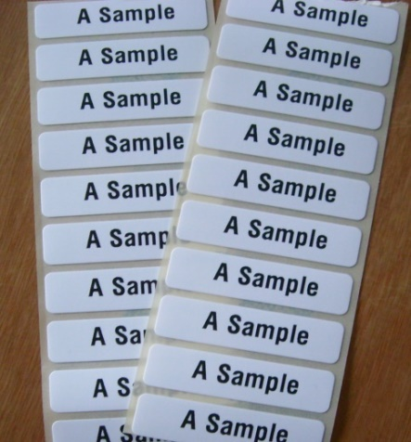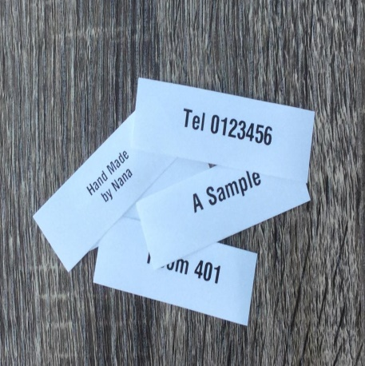

15 Iron On Name Labels £ 1.99 10 Sew On Labels £ 1.99
25 Iron On Name Labels £ 2.99 20 Sew On Labels £ 3.50
50 Iron On Name Labels £ 4.99 30 Sew OnLabels £ 5.00

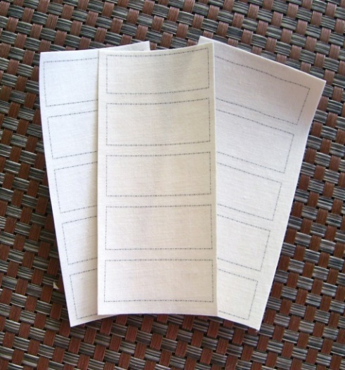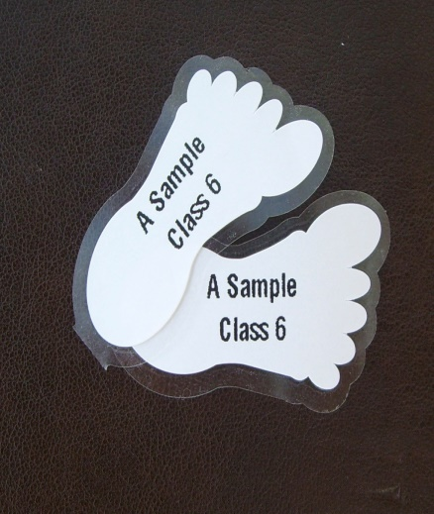

15 Plain Name Labels £ 0.99
25 Plain Name Labels £ 1.60 Peel & Stick Shoe Labels – 5 pairs for £1.50
50 Plain Name Labels £ 3.00

Order From - www.labelcreating.co.uk

Email - labelcreating@gmail.com

Tel - Marion - 07754 515586

