Otterbourne CE Primary School Calculation Policy (2023)
This document outlines the progression in calculation strategies used at Otterbourne CE Primary School.
At Otterbourne CE Primary School we believe that children should be introduced to the processes of calculation through practical, oral and mental activities in creative and meaningful ways.
Choosing the appropriate mathematical strategy is an important tool both for furthering the understanding of ideas, and for communicating those ideas to others. Written methods are complementary to mental methods and should not be seen as separate from them. The aim is that children use mental methods when appropriate, but for calculations that they cannot do in their heads they use an efficient method accurately and with confidence.
Children should move from concrete to pictorial to abstract techniques. A new concept should always be introduced with concrete resources before moving onto pictorial representations. Once children are confident with the fundamentals of the mathematical concept they are exploring through concrete and pictorial representations, they then should move onto the abstract representations.
In this document, the first two pages for each mathematical strand shows the National Curriculum objectives covered in each year group. The following pages show the progression of methods used to teach the concepts- these methods are not year group specific, and should be used as appropriate for the concept in hand, and as appropriate for each child’s understanding of a concept.

Key Stage 1
Year 1 | Year 2
- Read, write and interpret mathematical statements involving addition (+) and equals (=) signs.  - Represent and use number bonds and related addition facts to 20.  - Add one-digit and two-digit numbers to 20, including zero.  - Solve one-step problems that include addition, using concrete objects and pictorial representations, and missing number problems. | - Solve problems with addition:  - using concrete objects and pictorial representations, including those involving numbers, quantities and measures  - applying their increasing knowledge of mental and written methods.  - Recall and use addition facts to 20 fluently, and derive and use related facts up to 100.  - Add numbers using concrete objects, pictorial representations, and mentally, including:  - a two-digit number and ones  - a two-digit number and tens  - two two-digit numbers  - adding three one-digit numbers  - Show that addition of two numbers can be done in any order (commutative).  - Recognise and use the inverse relationship between addition and subtraction and use this to check calculations and solve missing number problems.
Vocabulary
add, more, plus, and, make, altogether, total, equals, double, most, count on, number line, tens, ones, partition, addition, column, exchanging
Addition

Key Stage 2
Year 3 | Year 4 | Year 5 | Year 6
- Add and subtract numbers mentally, including:  - a three-digit number and ones  - a three-digit number and tens  - a three-digit number and hundreds  - Add numbers with up to three-digits, using formal written methods of columnar addition and subtraction.  - Estimate the answer to a calculation and use inverse operations to check answers.  - Solve problems, including missing number problems, using number facts, place value, and more complex addition. | - Add numbers with up to 4 digits using the formal written methods of columnar addition where appropriate.  - Estimate and use inverse operations to check answers to a calculation.  - Solve addition two-step problems in contexts, deciding which operations and methods to use and why. | - Add whole numbers with more than 4 digits, including using formal written methods (columnar addition).  - Add numbers mentally with increasingly large numbers.  - Use rounding to check answers to calculations and determine, in the context of a problem, levels of accuracy.  - Solve addition multi-step problems in contexts, deciding which operations and methods to use and why. | - Solve addition multi-step problems in contexts, deciding which operations and methods to use and why.  - Use estimation to check answers to calculations and determine, in the context of a problem, an appropriate degree of accuracy.
Vocabulary
add, more, plus, and, make, altogether, total, equal to, equals, double, most, count on, number line, sum, thousands, hundreds, tens, ones, partition, addition, column, exchanging, increase, digits, inverse, decimal place, decimal point, tenths, hundredths, thousandths.

A  D  D  I  T  I  O  N  A  D  D  I  T  I  O  N | Method | Concrete | Pictorial | Abstract
A  D  D  I  T  I  O  N  A  D  D  I  T  I  O  N | Counting and combining sets of objects |   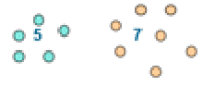  Children to count out the correct number of objects, and combine them to find the total number of objects. | 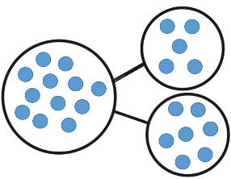  Using the part-whole model, children can draw their own examples of concrete objects. | 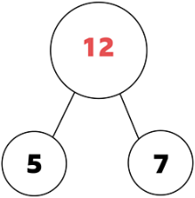  5 + 7 = 12  (5 is a part, 7 is a part, and the whole is 12)
A  D  D  I  T  I  O  N  A  D  D  I  T  I  O  N | Regrouping to make 10 | 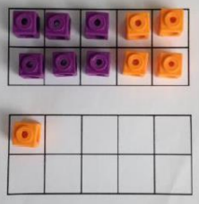  Using tens frames and counters / cubes or using numicon:  6 + 5 becomes  6 + 4 = 10  10 + 1 = 11 | 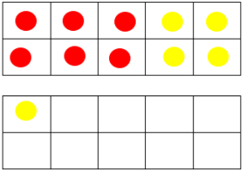  Children to draw the tens frame and counters / cubes: | Adding by bridging through 10 mentally.  6 + 5 = 11
A  D  D  I  T  I  O  N  A  D  D  I  T  I  O  N | Understanding of counting on a number line | 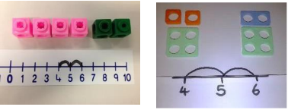  Counting on using number lines by using physical objects | 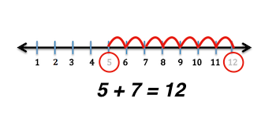  Counting on using jumps on a number line. | An abstract number line:  When confident on a number line, children will move onto drawing their own number line to support partitioning and bridging through 10:  Children will be able to decide upon appropriate jumps to make on a number line to support faster calculating.  23 + 12 =  23 + 10 + 2=  33 + 2 =  35
A  D  D  I  T  I  O  N  A  D  D  I  T  I  O  N | Partitioning | 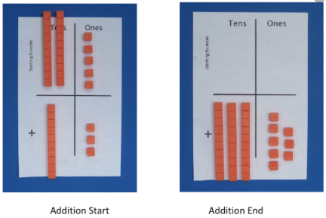  Using dienes to partition and then recombine:  This would move onto exchanging 10 ones for a rod of ten. | 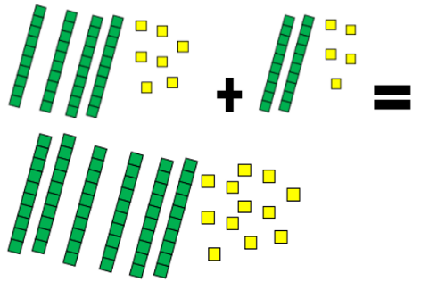  Children to represent the concrete using a particular symbol e.g. lines for tens and dots for ones. When exchanging occurs children can group the ten ones or cross them out and exchange for a ten. | Expanded written method using understanding of place value to support partitioning:  47 + 25 =  40 + 7 + 20 + 5 =  40 + 20 + 7 + 5 =  60 + 12 = 72
A  D  D  I  T  I  O  N  A  D  D  I  T  I  O  N | Bar Model | 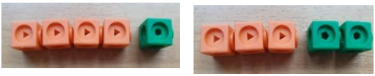  Using blocks to build a bar: | 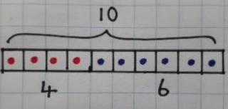  Drawing a bar model using images of concrete objects: | 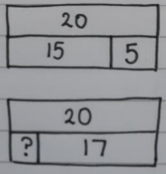  Using a bar model to  support understanding  of missing number  problems to support  understanding of using the inverse operation to check an answer
A  D  D  I  T  I  O  N  A  D  D  I  T  I  O  N | Columnar Addition | 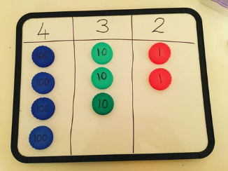  Using place value counters to build numbers in a place value grid.  E.g. 121 + 311 = 432  Once the children have had practice with this without exchanging, they should be able to apply it to larger numbers with the process of exchanging involved. | 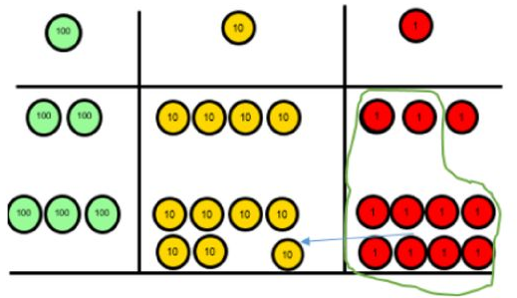  Children to represent their addition using images of place value counters / base 10, starting with no exchanging.  When the children have had practice, they should be able to apply to questions where exchanging is needed. | 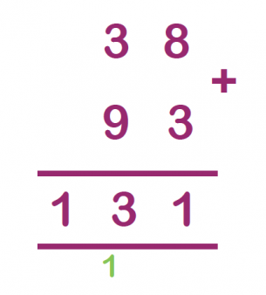  Written method of columnar addition:  Children will be able to place the digits from each number into the correct column, and show their exchanges.
A  D  D  I  T  I  O  N  A  D  D  I  T  I  O  N | Mental Methods should continue to develop, supported by a range of models and images, including the number line.
Key Stage 1
Subtraction

Year 1 | Year 2
- Read, write and interpret mathematical statements involving addition (+) and equals (=) signs.  - Represent and use number bonds and related addition facts to 20.  - Add one-digit and two-digit numbers to 20, including zero.  - Solve one-step problems that include addition, using concrete objects and pictorial representations, and missing number problems. | - Solve problems with addition:  - using concrete objects and pictorial representations, including those involving numbers, quantities and measures  - applying their increasing knowledge of mental and written methods.  - Recall and use addition facts to 20 fluently, and derive and use related facts up to 100.  - Add numbers using concrete objects, pictorial representations, and mentally, including:  - a two-digit number and ones  - a two-digit number and tens  - two two-digit numbers  - adding three one-digit numbers  - Show that addition of two numbers can be done in any order (commutative).  - Recognise and use the inverse relationship between addition and subtraction and use this to check calculations and solve missing number problems.
Vocabulary
Subtract, take away, minus, difference, less, less than, count back, number line, hundreds, tens, ones, partition, subtraction, column, place value, decrease, exchanging, digits, inverse.

Key Stage 2
Year 3 | Year 4 | Year 5 | Year 6
- Add and subtract numbers mentally, including:  - a three-digit number and ones  - a three-digit number and tens  - a three-digit number and hundreds  - Subtract numbers with up to three-digits, using formal written methods of columnar addition and subtraction.  - Estimate the answer to a calculation and use inverse operations to check answers.  - Solve problems, including missing number problems, using number facts, place value, and more complex addition. | - Subtract numbers with up to 4 digits using the formal written methods of columnar addition where appropriate.  - Estimate and use inverse operations to check answers to a calculation.  - Solve subtraction two-step problems in contexts, deciding which operations and methods to use and why. | - Subtract whole numbers with more than 4 digits, including using formal written methods (columnar subtraction).  - Subtract numbers mentally with increasingly large numbers.  - Use rounding to check answers to calculations and determine, in the context of a problem, levels of accuracy.  - Solve subtraction multi-step problems in contexts, deciding which operations and methods to use and why. | - Solve subtraction multi-step problems in contexts, deciding which operations and methods to use and why.  - Use estimation to check answers to calculations and determine, in the context of a problem, an appropriate degree of accuracy.
Vocabulary
Subtract, take away, minus, difference, less, less than, count back, number line, thousands, hundreds, tens, ones, partition, subtraction, column, place value, decrease, exchanging, digits, inverse, decimal place, decimal point, tenths, hundredths, thousandths.

S  U  B  T  R  A  C  T  I  O  N | Method | Concrete | Pictorial | Abstract
S  U  B  T  R  A  C  T  I  O  N | Taking away ones | 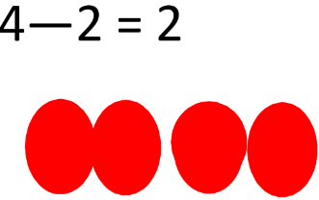  Children to count out the correct number of objects, and remove them to show taking away. |   Cross out drawn objects to show what has been taken away.  4- 2 = 2 | 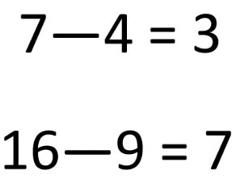  Children will be able to mentally calculate:
S  U  B  T  R  A  C  T  I  O  N | Understanding of counting on a number line |     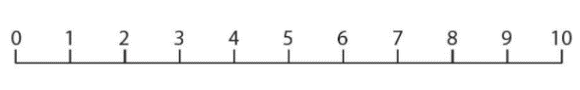  Counting back using number lines by using physical objects  5 – 4 = 1 | Counting back using jumps on a number line.  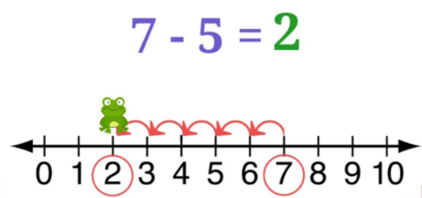 | 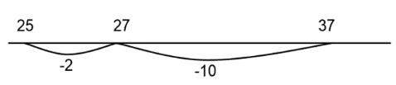  An abstract number line:  When confident on a number line, children will move ono drawing their own number line.  Children will be able to decide upon appropriate jumps to make on a number line to support faster calculating.
S  U  B  T  R  A  C  T  I  O  N | Partitioning | Using dienes to partition and then take away.  This would move onto exchanging a rod of ten for ten ones. | 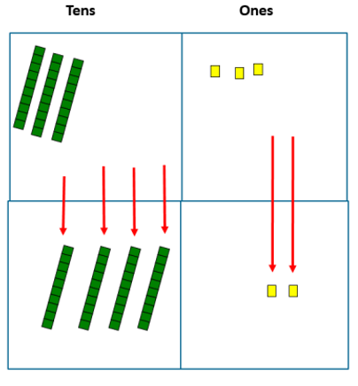  Children to represent the concrete using a particular symbol e.g. lines for tens and dots for ones. When exchanging occurs children can cross out the tens and exchange for ones cubes.  e.g. 75 – 42 = 33 | Expanded written method using understanding of place value to support partitioning:  75 – 42 =  70 – 40 = 30  5 – 2 = 3  30 + 3 = 33
S  U  B  T  R  A  C  T  I  O  N | Bar Model | Using blocks to build a bar:  5 – 4 = | Drawing a bar model using images of concrete objects:  10 – 4 = | 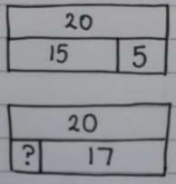  Using a bar model to  support understanding  of missing number  problems to support  understanding of using the inverse operation to check an answer
S  U  B  T  R  A  C  T  I  O  N | Columnar Subtraction | 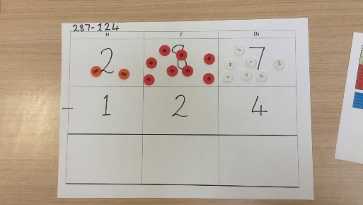  Using place value counters to build numbers in a place value grid.  Once the children have had practice with this without exchanging, they should be able to apply it to larger numbers with the process of exchanging involved. | Children to represent their addition using images of place value counters / dienes, starting with no exchanging.  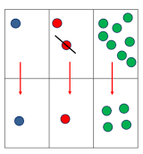  When the children have had practice, they should be able to apply to questions where exchanging is needed.  e.g. 232 – 114 = 118 | 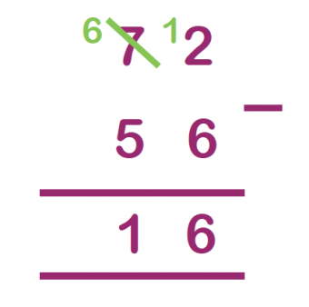  Written method of columnar subtraction:  Children will be able to place the digits from each number into the correct column, and show their exchanges.
S  U  B  T  R  A  C  T  I  O  N | Mental Methods should continue to develop, supported by a range of models and images, including the number line.

Multiplication

Key Stage 1
Year 1 | Year 2
- Solve one-step problems involving multiplication, by calculating the answer using concrete objects, pictorial representations and arrays with the support of the teacher. | - Recall and use multiplication facts for the 2, 5 and 10 multiplication tables, including recognising odd and even numbers.  - Calculate mathematical statements for multiplication within the multiplication tables and write them using the multiplication ( x ) and equals ( = ) signs.  - Show that multiplication of two numbers can be done in any order (commutative).  - Solve problems involving multiplication, using materials, arrays, repeated addition, mental methods and multiplication facts, including problems in contexts.
Vocabulary
Multiplication, multiply, times, groups of, lots of, equal groups, altogether, count, array, multiplied by, repeated addition, column, commutative, sets of.

Key Stage 2
Year 3 | Year 4 | Year 5 | Year 6
- Recall and use multiplication facts for the 3, 4 and 8 multiplication tables.  - Write and calculate mathematical statements for multiplication using multiplication tables that they know, including for two-digit numbers times one-digit numbers, using mental and progressing to formal written methods.  - Solve problems, including missing number problems involving multiplication, including positive integer scaling problems and correspondence problems in which n objects are connected to m objects. | - Recall multiplication facts for multiplication tables up to 12 x 12.  - Use place value, known and derived facts to multiply mentally, including: multiplying by 0 and 1; multiplying together three numbers.  - Recognise and use factor pairs and commutativity in mental calculations.  - Multiply two-digit and three-digit numbers by a one-digit number using formal written layout.  - Solve problems involving multiplying and adding, including the distributive law to multiply two digit numbers by one digit, integer scaling problems and harder correspondence problems such as n objects are connected to m objects. | - Identify multiples and factors, including finding all factor pairs of a number, and common factors of two numbers.  - Know and use the vocabulary of prime numbers, prime factors and composite (non-prime) numbers.  - Establish whether a number up to 100 is prime and recall prime numbers up to 19.  - Multiply numbers up to 4 digits by a one or two digit number using a formal written method, including long multiplication for two digit numbers.  - Multiply numbers mentally drawing upon known facts  - Multiply whole numbers and those involving decimals by 10, 100 and 1000. | - Multiply multi-digit numbers up to 4 digits by a two-digit whole number using the formal written method of long multiplication.  - Perform mental calculations.  - Identify common factors, common multiples and prime numbers.
Vocabulary
Subtract, take away, minus, difference, less, less than, count back, number line, thousands, hundreds, tens, ones, partition, subtraction, column, place value, decrease, exchanging, digits, inverse, decimal place, decimal point, tenths, hundredths, thousandths.

M  U  L  T  I  P  L  I  C  A  T  I  O  N | Method | Concrete | Pictorial | Abstract
M  U  L  T  I  P  L  I  C  A  T  I  O  N | Doubling | 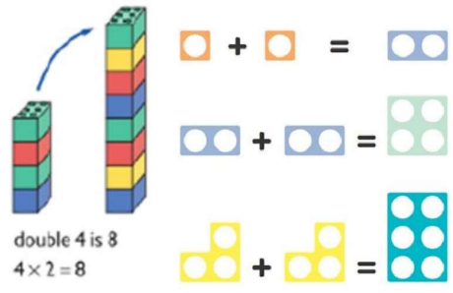  Using practical activities using manipulatives such as cubes and Numicon to demonstrate doubling. | 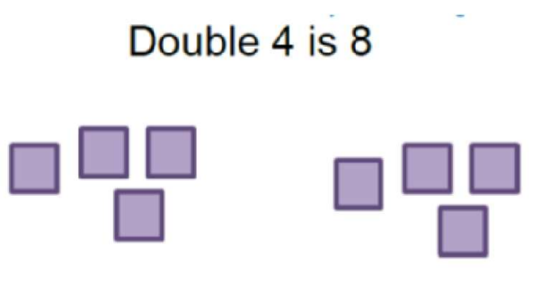  Draw pictures to show how to double numbers. | 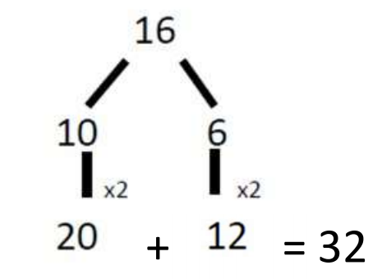  Partition a number and then double each part mentally before recombining it back together.
M  U  L  T  I  P  L  I  C  A  T  I  O  N | Making equal groups | 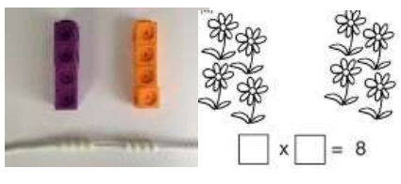  Using manipulatives to create equal groups to underpin understanding that ‘x’ means ‘equal groups of’. |   Draw images to show understanding of equal groups.  e.g. 3 x 6 = 3 groups of 6 | 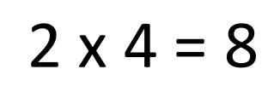  Applying understanding of equal groups to mental calculation.
M  U  L  T  I  P  L  I  C  A  T  I  O  N | Repeated addition | 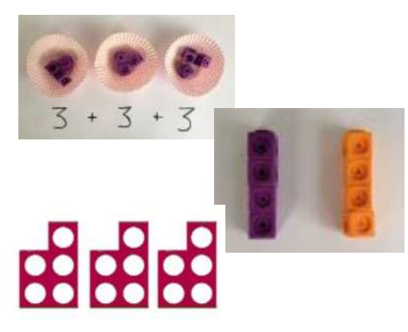  Using objects to add equal groups together. | 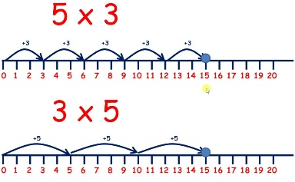  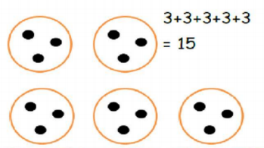  Use drawn images including number lines to solve multiplication problems.  Children can be  introduced to  commutativity. | 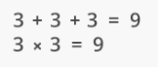  Writing addition sentences to describe a multiplication statement.

M  U  L  T  I  P  L  I  C  A  T  I  O  N | Arrays | 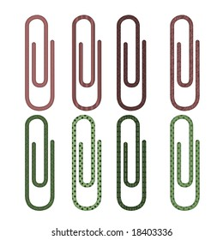  Use understanding of equal groups to make arrays using a range of materials.  2 x 4 = 8 | 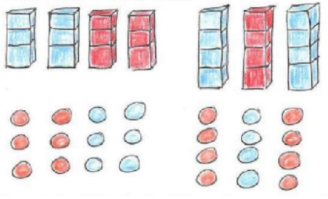  Draw representations of arrays.  3 x 4 = | 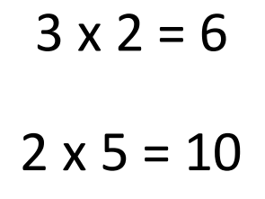  Representing multiplication questions through written statements.
M  U  L  T  I  P  L  I  C  A  T  I  O  N | Bar Model |   Use understanding of equal groups to build a bar model. | 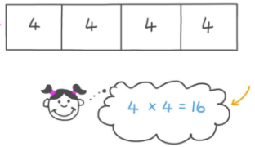  Draw a bar model to  represent equal groups. | Representing multiplication questions through written statements.
M  U  L  T  I  P  L  I  C  A  T  I  O  N | Grid Method | 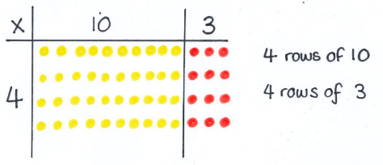  Using links with arrays to first introduce the grid method for multiplying larger numbers.  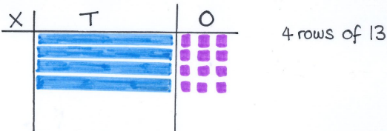  Moving onto dienes to move towards a more compact method.  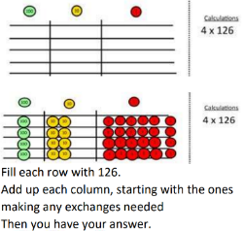  Move onto place value counters to show how we are finding groups of a number. | 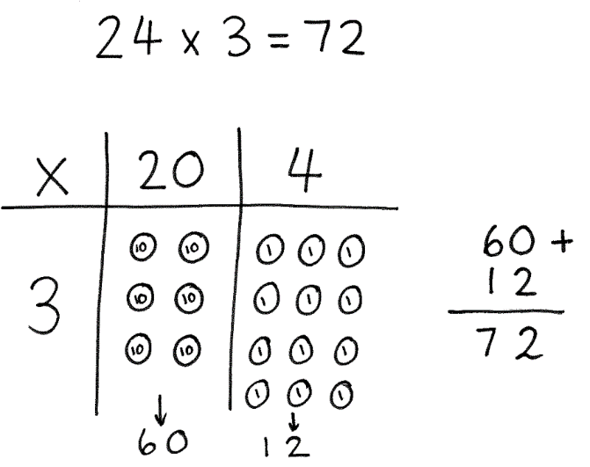  Draw objects in the correct columns to represent the numbers of the multiplication question. Children will be able to draw the correct number of groups to represent the calculation. | Drawing own grid and using written numbers within the grid to represent the calculation. This method can be used to multiply by a 1-digit, or a 2-digit number.  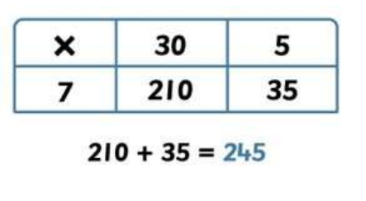  Children will use clear addition alongside the grid.
M  U  L  T  I  P  L  I  C  A  T  I  O  N | Column Multiplication | Initially with questions which require no regrouping, children can be supported with place value counters. The corresponding long multiplication can be modelled alongside the manipulatives.  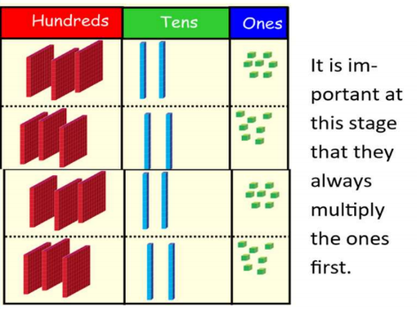 | 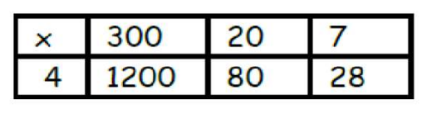  The grid method can be used to link into a formal written method.  Bar modelling and number lines can support learners when solving problems with multiplication alongside the formal written methods. | 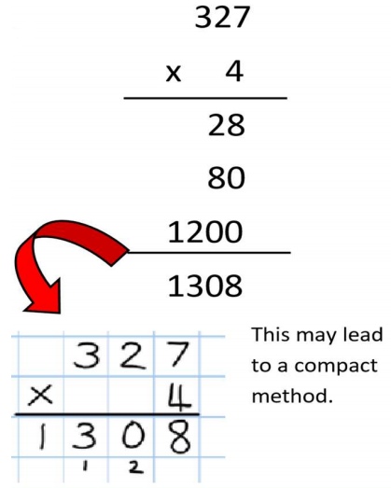  Children can start with an expanded column method, multiplying each part of the multiplicand by the multiplier, then adding together.
M  U  L  T  I  P  L  I  C  A  T  I  O  N | Mental Methods should continue to develop, supported by a range of models and images.  Multiplying by 10, 100 and 1000 should be carried out on a place value grid.

Division

Key Stage 1
Year 1 | Year 2
- Solve one-step problems involving division, by calculating the answer using concrete objects, pictorial representations and arrays with the support of the teacher. | - Recall and use division facts for the 2, 5 and 10 multiplication tables, including recognising odd and even numbers.  - Calculate mathematical statements for division within the multiplication tables and write them using the division ( ÷ ) and equals ( = ) signs.  - Show that multiplication of two numbers can be done in any order (commutative), and division of one number by another cannot.  - Solve problems involving division, using materials, arrays, repeated addition, mental methods and multiplication facts, including problems in contexts.
Vocabulary
Share, share equally, split, group, groups of, lots of, array, divide, divided by, divided into, division, grouping, number line, left, left over.

Key Stage 2
Year 3 | Year 4 | Year 5 | Year 6
- Recall division facts for the 3, 4 and 8 multiplication tables.  - Write and calculate mathematical statements for division using the multiplication tables they know, including for two-digit numbers times one-digit numbers, using mental and progressing to formal written methods.  - Solve problems, including missing number problems, involving division, including positive integer scaling problems and correspondence problems in which n objects are connected to m objects. | - Recall division facts for multiplication tables up to 12 x 12.  - Use place value, known and derived facts to divide mentally, including dividing. | - Divide numbers mentally drawing upon known facts.  - Divide numbers up to 4 digits by a one-digit number using the formal written method of short division and interpret remainders appropriately for the context.  - Divide whole numbers and those involving decimals by 10, 100 and 1000. | - Divide numbers up to 4 digits by a two-digit number using the formal written method of long division, and interpret remainders as whole number remainders, fractions, or by rounding, as appropriate for the context.  - Divide numbers up to 4 digits by two-digit number using the formal written method of short division where appropriate, interpreting remainders according to the context.  - Use their knowledge of the order of operations to carry out calculations involving the four operations.
Vocabulary
Share, share equally, split, group, groups of, lots of, array, divide, divided by, divided into, division, grouping, number line, left, left over, inverse, short division, remainder, multiple, factor.

D  I  V  I  S  I  O  N  D  I  V  I  S  I  O  N  D  I  V  I  S  I  O  N | Method | Concrete | Pictorial | Abstract
 | Sharing | 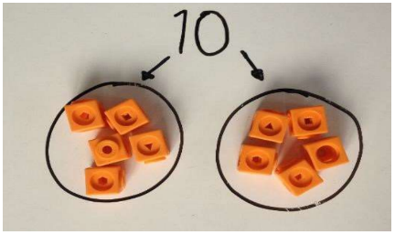  Using concrete objects to represent sharing an amount into equal groups. | 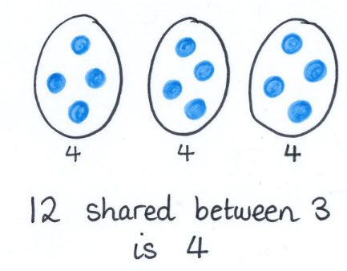  Using pictures or shapes to share quantities equally. | 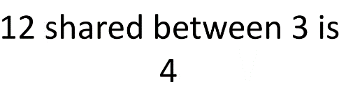  Using verbal or written statements to show understanding of sharing equally.
 | Grouping  (Number line & Bar Model) | 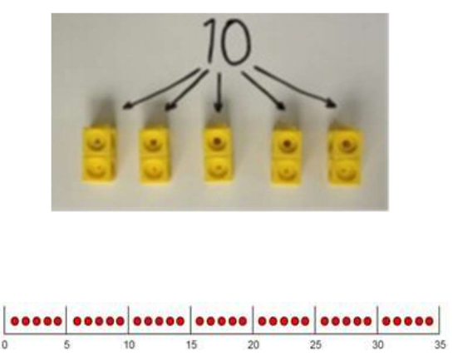  Using concrete objects to aid understanding of sharing quantities into equal groups. | Using drawn images to show understanding of grouping. This can be shown either through grouped jumps on a number line, or using a bar model which is split into the correct number of groups, with the starting amount shared equally between these groups.  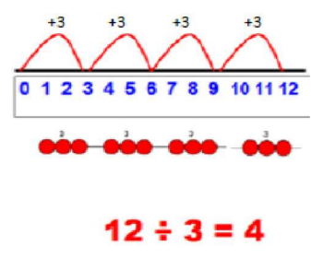  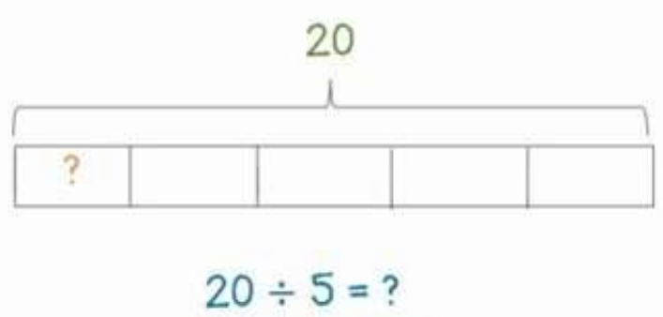 | 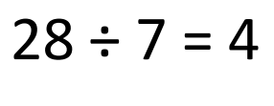  Children are able to talk about and calculate written statements mentally.
 | Arrays | 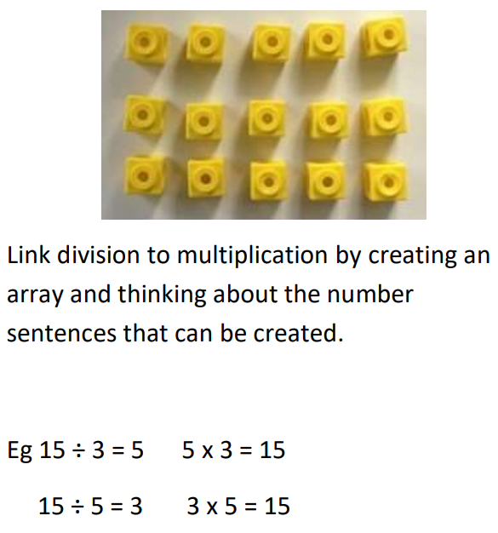 | 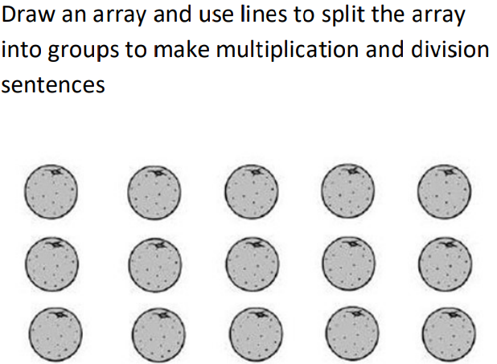  E.g. 15 ÷ 3 = 5 | 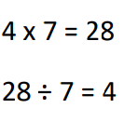  Find the inverse of multiplication and division by creating linking number sentences.
 | Division with remainders | 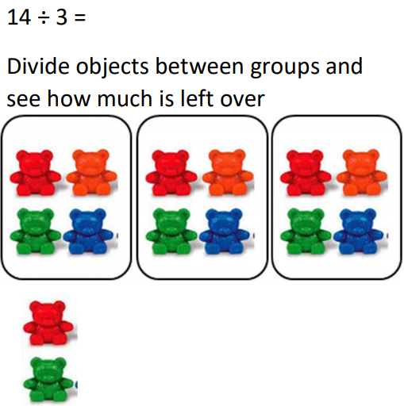 | Use drawn methods outlined above to explore remainders.  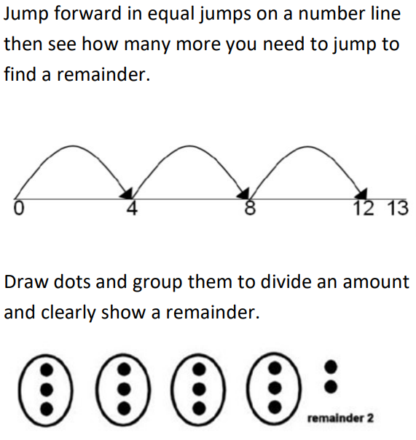  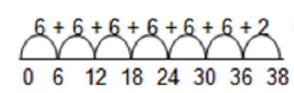 | 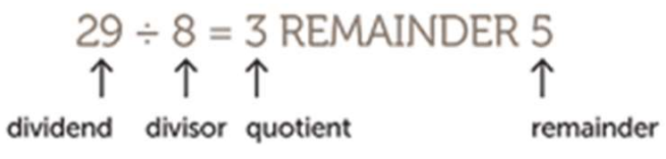  Complete written divisions and show the remainder using ‘r’.
 | Short Division | Using place value counters to model short division alongside the written method.  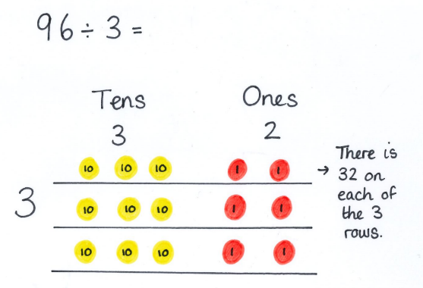  Children will need to be able to identify the divisor and split the dividend into the correct number of equal groups. | 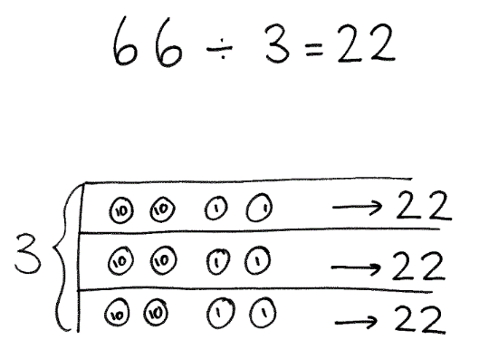  Children begin drawing counters to support the move into a formal written method. | 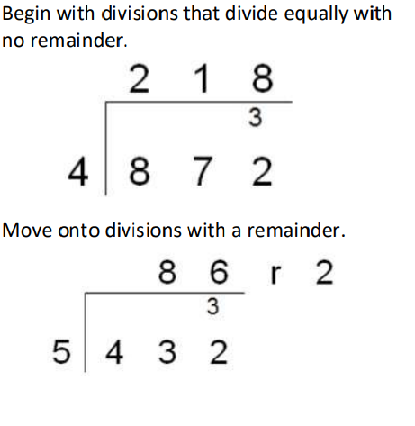  Short division:
D  I  V  I  S  I  O  N | Long Division  (Draw-down method) |  |  | 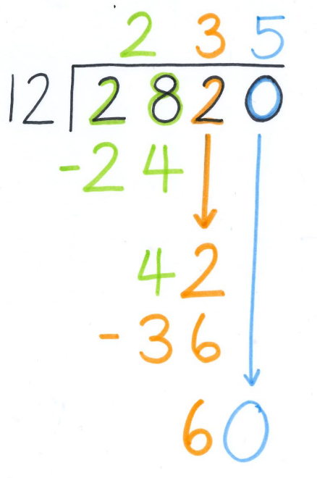  Children will build upon abstract understanding of short division, by using the method of long division to support dividing 2-digit numbers.  In Year 6, children will use knowledge of short and long division techniques to divide decimal numbers.
 | Mental Methods should continue to develop, supported by a range of models and images.

